Following updated is only available to new vocoder version; please check menu-utilities-radio info-versions- and if version begins from 013 rather than D002 or D003, you can use this updated firmware and if you radio is D002 or D003 version, please don’t use this firmware, or it will cause radios reboot all the time

Firmware version : TYT-Vocoder-MD380-D14.07.bin
Firmware version : TYT-Vocoder-MD390-D14.07.bin
Operation after updated:Press P1+P2 key to open the radio, can switch the VFO Locking and original and narrow band 150-160MHz &450-460MHz.This is for USA ham users.

Press side key 1 and PTT key to turn on the radio, the indicator blinks and open upgraded software
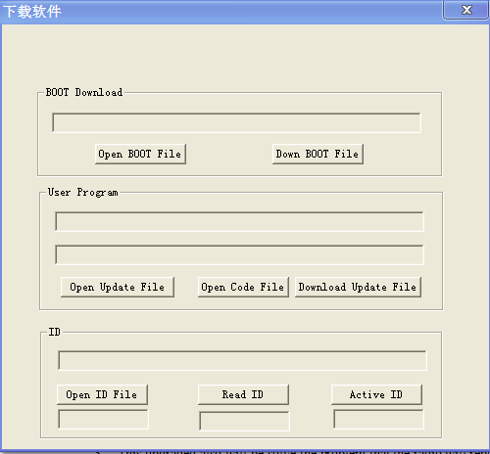

And then write upgraded file named Upgraded software for scanning function into radio, the radio will be upgraded as following:
